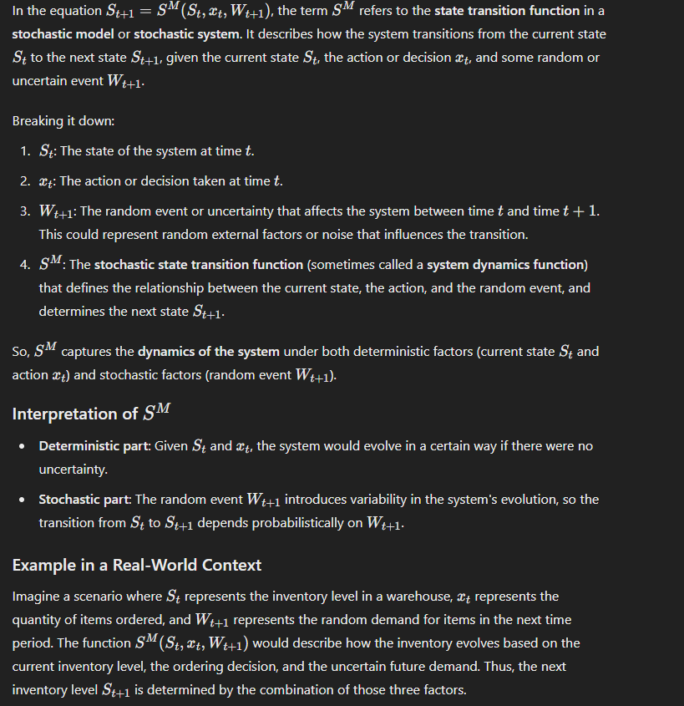

The **Stochastic-Dynamic Inventory Routing Problem (SDIRP)** for bike-sharing systems is called **stochastic** and **dynamic** because it involves both uncertainty (stochastic elements) and time-evolving decision-making (dynamic aspects). Here’s a breakdown of the terminology:

**1. Stochastic:**

The term *stochastic* refers to the presence of **uncertainty** in the system, specifically in **future demand** for bikes at different locations. In the context of bike-sharing systems, future demand for bikes is unpredictable—it may vary due to weather, time of day, or user behavior, which are difficult to precisely forecast.

In the SDIRP:

* **Time-dependent decisions**: Bike relocation decisions need to be made throughout the day based on the current state of the system (e.g., the number of bikes at each station), as well as anticipated future states.
* **Sequential decisions**: Decisions at time ttt affect the future state of the system at time t+1t+1t+1, meaning the problem unfolds over time, and each decision is part of a **sequential decision-making process**

2. **Dynamic**:

The problem is **dynamic** because it evolves over time, requiring decisions to be made **sequentially** at multiple points during the day. This means that the system’s state (e.g., the number of bikes at each station) changes as bikes are picked up, dropped off, or relocated, and the decision-maker needs to adjust their actions in response to these changes as time progresses.

In the SDIRP:

* **Time-dependent decisions**: Bike relocation decisions need to be made throughout the day based on the current state of the system (e.g., the number of bikes at each station), as well as anticipated future states.
* **Sequential decisions**: Decisions at time ttt affect the future state of the system at time t+1t+1t+1, meaning the problem unfolds over time, and each decision is part of a **sequential decision-making process**.